APPLICATION FORM

TO PARTICIPATE IN INTERNATIONAL COMPETITION 26.12-29.12.2019

“WORLD MUSIC ART – SILVER PALM HELSINKI 2019”

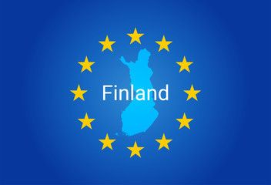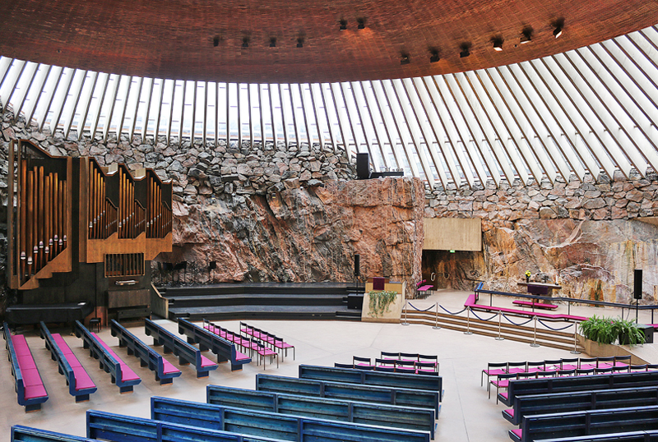

Temppeliaukio Church
Lutherinkatu 3 00100 Helsinki

Supple profiles to 20.11.2019 melodyluxart@gmail.com
SOLOIST  or ORIGINAL GENRE | INSTRUMENTALIST | ENSEMBLE | CHOIR
- A - 7- 12  - B - 13 - 15  - C - 16 - 18  - D - 19 - 23  - E - 24 - 30  - F - 30 + | - A - 7- 12  - B - 13 - 15  - C - 16 - 18  - D - 19 - 25  - E - 26 - 30  - F - 30 + | - A - 7- 12  - B - 13 - 15  - C - 16 - 18  - D - 19 - 25  - E - 26 – 30  - F - 30 + | - A - 7- 12  - B - 13 - 15  - C - 16 - 18  - D - 19 - 30  - F - 30 +
Surname, name

Date of Birth

Citizenship, country, city

Full name of the head

Phone

e-mail

Address

Links party songs Youtube

Short creative biography
Your program | Composer/Authors | The name of song/s |  | Duration
- Yes/No  Do you need an accompanist/ 30 euro |  | - Yes/No  I have an accompanist  Surname, name
Day, time and plays of arrival | Day, time of departure | - Yes/No  Festival Package

I do not mind that the above mentioned product, if necessary, will be used in audio and video recordings

_____________________ _____________________________
(Full name of the head) (Signature)

